THIS IS NOT A FINISHED GAME. It was never going to be.

Tutorial

Goal

The people on Terra have exhausted all resources on the planet! As a last resort, all countries on Terra have unified, to create the Commonwealth of Man. You have been appointed as President of Resources for the new Commonwealth, and it is your duty to ensure proper expansion to other worlds to get more resources. You need to act quickly, Terra already doesn’t have any more room to expand, and pollution is affecting the health of billions of humans already. If you can get the net population above 75, you will go down in history as the saviour of all Humans! But if the net population falls below 75, you’ll be forced to retire, and end the game.



Solar System

Your Solar System is made up of Skei, Terra, Morp, Cronus, and Altzeira. All but Terra is uninhabited. In this screen of the game, your ship is represented by a grey circle, and you can move between different planets by pressing the WASD keys. To land on a planet in this mode, you can press SPACE.

GUI

This is the GUI for when you have landed on Terra. The tiles in the centre of the screen represent an area on each planet. The slightly darker tiles are uninhabitable. To the left of the screen are the global resources. These are ones that are shared between all planets. These serve just to give a general idea of how things are going as a whole. Down the bottom are all of the resources that are being produced and used on each planet. When building on a planet, the resources required for building will be taken from the planet that it is built on, but if the resource is global, provided the net global for the resource is above what is needed, the planet doesn’t need to produce that resource, and it will just take from the global supply. Clicking the ‘Return to Solar System’ down the bottom will return you to the solar system state, as will pressing SPACE or ESCAPE. You can click on the planets on the right side of the screen to easily navigate between different planets. The text for resources here can also give you a quick indication of how resources are on other planets.

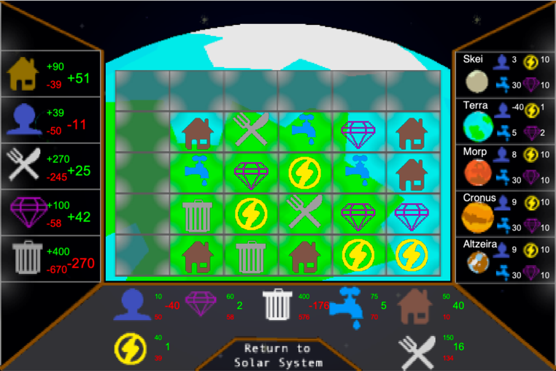

Tile Improvements

Clicking on a tile will show this dropdown. The first 2 options will expand and give you an extra dropdown, and the last 2 directly do actions. The Clear Tile button will remove whatever improvement you had on the tile and get rid of whatever the tile was producing. It produces 30 pollution and doesn’t refund the original cost of the tile. As a result of this, this button should only be used when really needed. The Build Resettlement button will build a new colony on a planet, and so is useful when starting a planet, or when a planet is on the brink of collapse. The first time you build this on a planet, it’s free, but does take 30 seconds. After the first time it takes 2 population and 30 food. It gives you a good amount of resources to get the planet started, but nothing else can be built on the planet while this is being constructed.

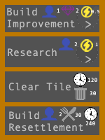

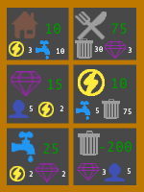

Building Improvements

The cost to build any improvement is 1 population, 2 minerals, 0.5 energy, plus whatever the 2 resources down the bottom of the resource say. For example, for housing, it costs 1 population, 2 minerals, and 0.5 energy, plus 3 energy, 10 water, to produce 10 housing for that planet.

Research

The cost to research anything is 2 population plus 1 energy plus whatever resource is at the bottom of the research that you want and will also take 60 seconds. For example, to research housing would cost 2 population, 1 energy, and 50 minerals and will take 60 seconds. During this 60 second period nothing else can be done on the planet. Once done, the 2 population and 1 energy will be refunded, and the resource will be improved by 15%.

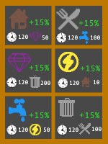



Population

Population is the most vital resource in the game. 1 Population will consume 3 food, 1 housing, and produce 2 pollution. If the pollution on the planet is below 0, population will randomly start to die based on numbers of population and how bad the pollution is. This is the same for housing and food. When population die, housing and food increase, but pollution stays the same. If pollution is positive, however, meaning there is more pollution being treated than being produced, population will start to increase. This is the same with food. If net population is negative, it means there are more jobs than population, and if this gets to -75, you lose. Your goal is to have +75 population, meaning there are 75 more population that required.